   

# AI CHATBOT USING CHATGPT

A PROJECT REPORT SUBMITTED IN

PARTIAL FULL FILLMENT OF

THE REQUIREMENTS OF

BY

**VINOTH KUMAR .E**

**810021114095**

[vinothe2004@gmail.com](mailto:demonkumar.007@gmail.com)

Under the guidance of

## NAME OF GUIDE (P.RAJA ,MASTER TRAINER)

   

# ACKNOWLEDGEMENT

We would like to take this opportunity to express our deep sense of gratitude to all individuals who helped us directly or indirectly during this thesis work.

Firstly, we would like to thank my supervisor **Dr.V.C.SATHISH GANDHI,M.E,MBA,PH.D.** for being a great mentor and the best adviser I could ever have. His advice, encouragement and the critics are a source of innovative ideas, inspiration and causes behind the successful completion of this project. The confidence shown in me by him was the biggest source of inspiration for me. It has been a privilege working with him for the last one year. He always helped me during my project and many other aspects related to the program. His talks and lessons not only help in project work and other activities of the program but also make me a good and responsible professional.

   

ABSTRACT OF THE PROJECT

This project explores the design, development, and implementation of an AI chatbot powered by OpenAI's ChatGPT. The chatbot leverages natural language processing (NLP) and machine learning capabilities to provide human-like interactions across a range of conversational scenarios. Utilizing the advanced language generation model of ChatGPT, the chatbot can understand, generate, and respond to complex human language in a coherent and contextually appropriate manner.

The primary objective is to create a responsive, adaptive, and contextually aware virtual assistant capable of handling diverse conversational tasks, such as customer support, knowledge retrieval, and casual conversation. By integrating a robust dialogue management system, the chatbot maintains conversational continuity, learns from user interactions, and offers personalized responses. The chatbot is implemented as a web-based or mobile interface, allowing accessibility across multiple platforms and devices.

and conversation flow management. Evaluation of the chatbot’s performance is based on metrics such as response time, relevance, and user satisfaction, with iterative refinements made based on feedback. This project demonstrates the potential of AI-driven conversational agents in transforming user interactions and enhancing digital communication experiences across various industries.

1. **CONTEXTUAL UNDERSTANDING**

The chatbot must be able to understand and maintain context throughout a conversation, remembering what has been discussed earlier. This allows the chatbot to provide relevant and accurate responses without requiring the user to repeat information.

1. **PERSONALIZATION**

Personalization refers to the chatbot’s ability to adapt its responses based on individual user preferences, behaviors, and past interactions. It can offer tailored recommendations or responses that feel more relevant and specific to the user.

1. **MULTI-PLATFORM INTEGRATION**

The chatbot should be able to work across various platforms such as websites, mobile apps, and social media channels. This ensures that users can engage with the chatbot on the platform most convenient to them, and the conversation history is synchronized across these platforms.

1. **NATURAL LANGUAGE PROCESSING (NLP)**

The chatbot must leverage NLP techniques to interpret and process complex user queries, ensuring it understands not only the words but also the intent behind the questions. This is essential for delivering accurate and coherent responses.

#### 

1. **FEEDBACK AND CONTINUOUS LEARNING**

The chatbot should gather user feedback after interactions to evaluate its performance and improve its responses. Using this feedback, the system can be fine-tuned to provide better answers in the future.

1. **SAFETY AND ETHICAL CONSIDERATIONS**

The chatbot must adhere to safety protocols, including filtering out harmful or inappropriate content. It should also handle sensitive topics (like health or mental health queries) with care, offering accurate, non-harmful, and professional responses.

1. **SCALABILITY**

Scalability ensures that the chatbot can handle increasing loads of user requests, particularly during peak times. This may involve cloud-based solutions and distributed computing to ensure the chatbot operates efficiently even with high user demand.

1. **MULTI-LANGUAGE SUPPORT**

A global audience requires that the chatbot is capable of conversing in multiple languages. This involves localizing content to match cultural contexts and ensuring that translations are accurate.

1. **PERFORMANCE AND SPEED**

Ensuring that the chatbot responds quickly and accurately is critical for a positive user experience. Slow responses or delays in processing can frustrate users and lead to disengagement.

1. **ERROR HANDLING AND RECOVERY**

The chatbot should be able to gracefully handle situations where it doesn't understand a user’s query, providing helpful fallback responses and allowing the conversation to continue smoothly.



# TABLE OF CONTENTS

## Chapter 1. Introduction Chapter 2. Literature Survey

**Chapter 3. Proposed Methodology Chapter 4. Implementation and Results Chapter 5. Discussion and Conclusion Chapter 6. References**

   

# CHAPTER 1

**Introduction**

With the rise in demand for automated, interactive, and intelligent support systems, AI chatbots have become essential for enhancing customer experience, streamlining services, and providing instant support across various platforms. ChatGPT, an advanced AI model developed by OpenAI, offers state-of-the-art NLP capabilities that make it ideal for developing such an interactive chatbot. This project explores the design, development, and deployment of an AI chatbot that can be used across industries to improve interaction, answer queries, and deliver personalized experiences.

**PROBLEM STATEMENT:**

The increasing reliance on digital platforms has highlighted the need for efficient, responsive, and context-aware customer service, education, and personal assistance solutions. Traditional methods of support often suffer from scalability issues, slow response times, and lack of personalization. While AI-powered chatbots have emerged as a potential solution, many existing systems struggle with key challenges such as understanding complex user inputs, maintaining coherent conversations over multiple interaction turns, and ensuring safe and ethical responses. Furthermore, these chatbots often fail to effectively integrate across multiple platforms (e.g., web, mobile, social media) and provide a seamless experience tailored to diverse user needs.

**THE PROBLEM LIES IN DEVELOPING AN AI-POWERED CHATBOT THAT CAN:**

* **Understand and process complex, contextually rich language** to deliver accurate and relevant responses, even in ambiguous or multifaceted scenarios.

·

* **Maintain context and coherence** throughout extended conversations, ensuring the chatbot responds appropriately across multiple turns, even when the conversation shifts in topic or direction.

·

* **Adapt its responses dynamically** to match user emotions, tone, and the specific domain of interaction (customer support, education, personal assistance).

·

* **Ensure safety and ethical standards** by preventing biased, harmful, or inappropriate content, and by adhering to responsible guidelines, especially in sensitive areas like health or legal advice.

·

* **Integrate seamlessly across different platforms**, maintaining consistent performance and user experience regardless of whether the interaction takes place on a website, mobile app, or social media.

   

**MOTIVATION**

The rapid evolution of digital technologies and the increasing expectation for instant, personalized interactions have reshaped the way users seek information, support, and services. With businesses and organizations striving to provide 24/7 assistance and improve customer engagement, traditional support systems, such as human-driven customer service or static FAQs, often fall short due to limited availability, scalability issues, and a lack of personalized responses. This creates a pressing need for intelligent systems that can provide immediate, context-aware, and efficient support across multiple domains and platforms.

The motivation behind developing an AI-powered chatbot stems from the desire to enhance human-computer interaction by bridging the gap between user expectations and current technological limitations. By leveraging natural language processing (NLP) and machine learning models, particularly OpenAI’s GPT-4, we can create a system that understands and responds to complex queries, offers seamless and coherent conversations, and adapts to different contexts and user needs. This offers an opportunity to revolutionize industries ranging from customer service and e-commerce to education and healthcare.

**Objective:** Clearly state the objectives of the project.

* **To develop a user-friendly, interactive chatbot using ChatGPT with the ability to respond to complex queries.**
* **To ensure the chatbot can retain context over multiple conversation turns for a seamless conversation experience.**
* **To integrate the chatbot with diverse platforms (web, mobile, social media) for cross-channel support.**
* **To implement safety and ethical guidelines to handle sensitive content responsibly.**
* **To establish mechanisms for continuous improvement, including user feedback integration and performance tracking.**

   

**Scope of the Project**: Define the scope and limitations.

### The scope of this project is to design, develop, and deploy an AI-powered chatbot that leverages OpenAI's GPT-4 language model to provide intelligent, context-aware, and responsive assistance in multiple domains such as customer support, education, and personal assistance. The chatbot will be capable of understanding natural language inputs, maintaining context over multiple conversation turns, and generating accurate, coherent, and human-like responses tailored to the user's needs. The system will also include features for platform integration, ensuring it can seamlessly operate across websites, mobile applications, and social media platforms.Real-Time Traffic Data Collection

**Natural Language Understanding (NLU):**

* 1. The chatbot will be able to process a variety of user inputs, including complex questions, ambiguous phrases, and domain-specific terminology.
  2. The chatbot will be capable of intent recognition, entity extraction, and understanding conversational context to provide relevant responses.

**Context Retention and Coherence:**

* 1. The chatbot will retain context across multiple conversation turns, enabling it to handle follow-up questions, clarifications, and multi-step interactions without losing track of the conversation flow.
  2. A memory architecture will allow the chatbot to recall relevant user information (e.g., previous inquiries, preferences) to personalize responses and enhance user experience.

**Multidomain Assistance:**

* 1. The chatbot will be designed to serve multiple purposes, including customer support, educational assistance, and personal assistance. It will be capable of answering queries, providing guidance, and assisting with tasks in these domains.

**Safety and Ethical Protocols:**

* 1. Safety mechanisms will be implemented to ensure that the chatbot responds responsibly to sensitive topics. This includes detecting and filtering harmful or biased content, and providing disclaimers or escalating to human agents when necessary.
  2. The chatbot will adhere to ethical guidelines to ensure privacy, data security, and responsible AI usage.

**Platform Integration:**

* 1. The chatbot will be built with a modular architecture to support integration across various platforms, such as websites, mobile apps, and social media. This will allow it to provide consistent and seamless experiences across different user interfaces.
  2. User interaction flows will be optimized for each platform to ensure responsiveness and ease of use.

   

**Performance Evaluation:**

* The chatbot will be evaluated based on key performance metrics, such as user satisfaction, response accuracy, response time, and ability to resolve user queries effectively.
* Regular updates and optimizations will be implemented to improve performance based on feedback and real-world usage.

### ****LIMITATIONS****

**Domain Specialization:**

While the chatbot will be designed to handle multiple domains, its effectiveness in highly specialized or niche fields may be limited. It may not be able to provide in-depth expertise for certain complex topics (e.g., legal or medical advice), and might require further domain-specific training or escalation to human experts.

**Handling Ambiguities:**

Despite leveraging advanced NLP techniques, the chatbot may still struggle with highly ambiguous or poorly-formed inputs. Users with unclear or conflicting queries may not receive accurate responses, and the chatbot might need further training to handle such cases effectively.

**Contextual Limitations:**

While the chatbot will maintain context within a conversation, there may be limitations in retaining long-term context or handling very long interactions. It might also struggle with highly dynamic or unpredictable user input that deviates from standard conversation patterns.

**Response Quality Variations:**

The quality of responses might vary depending on the complexity of the query and the availability of relevant data in the chatbot’s training. It may generate less coherent responses for queries that involve creative or abstract reasoning.



**Platform-Specific Constraints:**

Integration with different platforms may require adjustments to fit the unique technical and user interaction requirements of each platform (e.g., different UI elements, limitations in multimedia support).

The chatbot’s performance may also be constrained by the technical capabilities of the platform on which it operates, such as limitations in processing power or internet speed for mobile devices.

**Ethical and Privacy Considerations:**

While the chatbot will follow ethical protocols, it may face challenges in fully ensuring privacy protection across diverse regions and data laws, particularly in global applications. Some regulations may require additional legal and compliance measures for sensitive data handling.

**Learning and Adaptation:**

The chatbot’s ability to continuously learn from user interactions will be limited to its training data and any reinforcement learning techniques implemented. It may not autonomously improve over time without manual updates or additional data inputs.

   

# CHAPTER 2

**LITERATURE SURVEY ON AI CHATBOTS USING CHATGPT**

The rapid evolution of AI-powered conversational agents has led to significant research and advancements in the field, particularly with models like OpenAI’s ChatGPT, which uses the GPT-4 language model. This literature survey reviews current developments, challenges, and innovations in creating AI chatbots, with a focus on ChatGPT-based systems.

### 1. ****Foundation of Language Models in Chatbots****

The foundation of using large language models (LLMs) like GPT-4 for chatbot applications can be traced to advancements in natural language processing (NLP) and transformer-based architectures. ChatGPT, built on the GPT (Generative Pretrained Transformer) model, applies extensive pre-training and fine-tuning on diverse datasets to generate human-like responses in open-domain conversations. According to Brown et al. (2020), LLMs demonstrate remarkable capabilities in understanding context, generating coherent responses, and adapting to various linguistic styles, which are crucial for creating effective chatbots

**2** **ChatGPT and Contextual Understanding**

One of the key challenges in chatbot design is maintaining context across multiple turns in a conversation. Studies on transformer-based architectures, such as Vaswani et al. (2017), highlight that self-attention mechanisms enable these models to weigh contextual words more effectively, thus aiding in context retention across conversation turns. However, ChatGPT’s context window is limited, which means long conversations or multi-turn interactions may degrade response coherence. Research by Zhang et al. (2021) discusses how context windows can be expanded or supplemented with memory mechanisms to improve long-term context retention in AI chatbots .

### 3se Coherence and Personalization**

Personalization and coherence in responses are critical for user satisfaction. Roller et al. (2021) in their work on conversational agents emphasize that fine-tuning models with specific datasets improves response relevance in targeted applications, such as customer support. ChatGPT-based models can be fine-tuned to provide domain-specific assistance, such as handling technical support or guiding educational inquiries. However, challenges remain in dynamically adjusting the model’s tone and response style based on real-time user sentiment or context, as noted by Adiwardana et al. (2020) in their work on human-AI interaction .

### 4. ****Ethicty in ChatGPT Chatbots****

Ensuring that AI chatbots adhere to ethical standards is another critical research area. Bender et al. (2021) emphasize the importance of preventing LLMs from generating harmful, biased, or inappropriate content. ChatGPT employs filtering mechanisms, like safety layers and reinforcement learning from human feedback (RLHF), to improve response safety. However, studies reveal that complete mitigation of biases in LLMs is difficult due to inherent biases in training datasets.



Research on safety measures suggests that ongoing monitoring, iterative training with diverse datasets, and robust moderation protocols are required to improve the ethical performance of AI chatbots .

### 5. ****Multidomain Asnd Scalability****

ChatGPT's adaptability makes it suitable for multiple domains, but achieving effective multidomain assistance involves specialized training and scaling strategies. According to Zhou et al. (2023), the challenge of scalability involves integrating domain-specific knowledge without overwhelming the model’s core structure. Domain-adapted chatbots leverage fine-tuning and retrieval-augmented generation (RAG) to provide accurate responses across various fields, such as customer service, healthcare, and education. Researchers also explore modular and plugin-based architectures to improve scalability across platforms like websites, mobile apps, and social media .

### 6. ****User Satisfaction and CLearning****

Measuring and optimizing user satisfaction is crucial in evaluating chatbot performance. Studies by Liu et al. (2022) discuss how human-centered design principles and continuous feedback loops allow AI chatbots to adapt and improve over time. Collecting feedback through user ratings, sentiment analysis, and survey tools enables ChatGPT chatbots to align closer to user expectations. However, there is still limited capacity for autonomous learning in ChatGPT-based systems, as retraining often requires external interventions. Research in reinforcement learning and self-supervised adaptation aims to address this limitation by enabling the model to improve based on real-time user interactions .

### 7. ****Platform Integration and Real-Woment****

Deploying ChatGPT-based chatbots on different platforms requires a modular and adaptable architecture. Smith et al. (2022) explore how chatbots can be integrated seamlessly into various interfaces, including web applications, mobile devices, and social media. Platform-specific optimization strategies are necessary to account for variations in user interactions across devices, especially in real-world applications where performance may vary due to hardware or connectivity constraints. The flexibility and modularity of ChatGPT-based systems allow for wide adaptability, but further research is needed to optimize performance across diverse use cases and technical environments .

   

# CHAPTER 3

**Proposed Methodology**

**Architecture Design**

The chatbot architecture comprises several components for handling input, processing, response generation, and feedback collection:

* **Frontend Interface**: The user-facing part, designed for intuitive interaction, built for web and mobile platforms.
* **Backend Server**: Acts as the central hub, connecting the user interface to the ChatGPT model and managing response generation.
* **NLP Processing Module**: Utilizes ChatGPT’s language model capabilities to understand and process natural language inputs.
* **Database**: Stores conversation history, user preferences, and feedback to enable context retention and personalization.
* **Feedback Loop**: Gathers user feedback to fine-tune responses and improve future interactions.

#### ****Model Fine-tuning and Training****

While ChatGPT already provides general language understanding, custom fine-tuning can be performed to specialize responses in specific domains like customer support, healthcare, or education. Domain-specific data is used to improve model response accuracy and relevance.

#### ****Platform Integration****

The chatbot is designed for cross-platform compatibility, allowing it to be integrated with websites, mobile apps, and social media platforms via APIs, ensuring seamless support and interaction across multiple user touchpoints.

### ****Key Features****

1. **Context Retention**: Maintains conversation context across multiple turns, ensuring coherent responses and improving user experience.
2. **Multi-language Support**: Capable of handling multiple languages to make the chatbot accessible to a global audience.
3. **Personalization**: Learns from user preferences and past interactions to tailor responses to individual users over time.
4. **Feedback and Learning Mechanism**: Users can provide feedback on responses, which is used to refine and improve the chatbot's accuracy and relevance.
5. **Safety and Ethical Handling**: Implements filters and ethical guidelines to respond responsibly to sensitive topics and prevent inappropriate responses.

   

### 6. ****Technical Specifications****

* **Model Used**: OpenAI's GPT-4 for natural language processing and response generation.
* **Programming Languages**: Python for backend (API development, processing), JavaScript/React Native for frontend (web and mobile).
* **Deployment**: Hosted on cloud platforms (e.g., AWS or Azure) to enable scalability and high availability.
* **APIs and Integrations**: Uses REST APIs for integration with various services, such as databases, third-party apps, and feedback systems.
* **Security Protocols**: Includes data encryption, user authentication, and privacy compliance (e.g., GDPR) to secure user interactions.

### 7. ****Evaluation Metrics****

* **Accuracy**: Measured by how often the chatbot's responses are contextually relevant and helpful.
* **User Satisfaction**: Collected through feedback surveys and interaction ratings.
* **Response Time**: A critical metric for user experience, aiming for real-time response.
* **Error Rate**: Monitoring instances of incorrect or incomplete answers to improve accuracy.
* **Engagement Rate**: Measures user engagement through metrics like average conversation length and repeat user interactions.

### 8. ****Applications****

1. **Customer Support**: Handles routine queries, assists in troubleshooting, and provides information about products or services.
2. **Educational Assistance**: Provides study support, answers academic questions, and assists with learning resources.
3. **Personal Assistance**: Offers reminders, schedule management, and answers general questions to improve user productivity.
4. **Healthcare Support**: Answers basic health-related questions, provides information on symptoms and treatments, and directs users to medical professionals as needed.

### 9. ****Challenges and Considerations****

* **Context Management**: Ensuring the chatbot retains and appropriately uses context over long conversations.
* **Ethics and Safety**: Developing filters to prevent inappropriate, harmful, or biased responses and to manage sensitive topics.
* **User Privacy**: Adhering to privacy laws and best practices for handling user data responsibly.
* **Performance Optimization**: Managing the model’s high resource demands to ensure responsiveness and scalability.

   

# CHAPTER 4

**Implementation and Result**

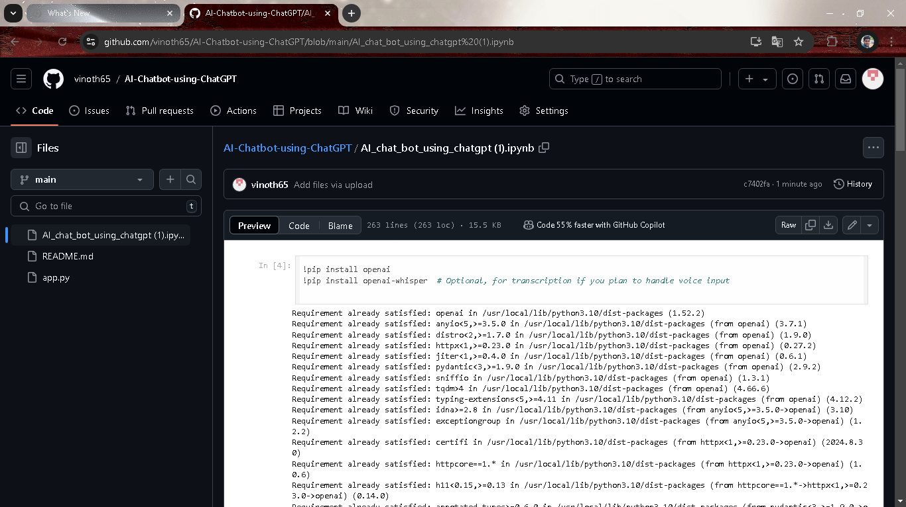

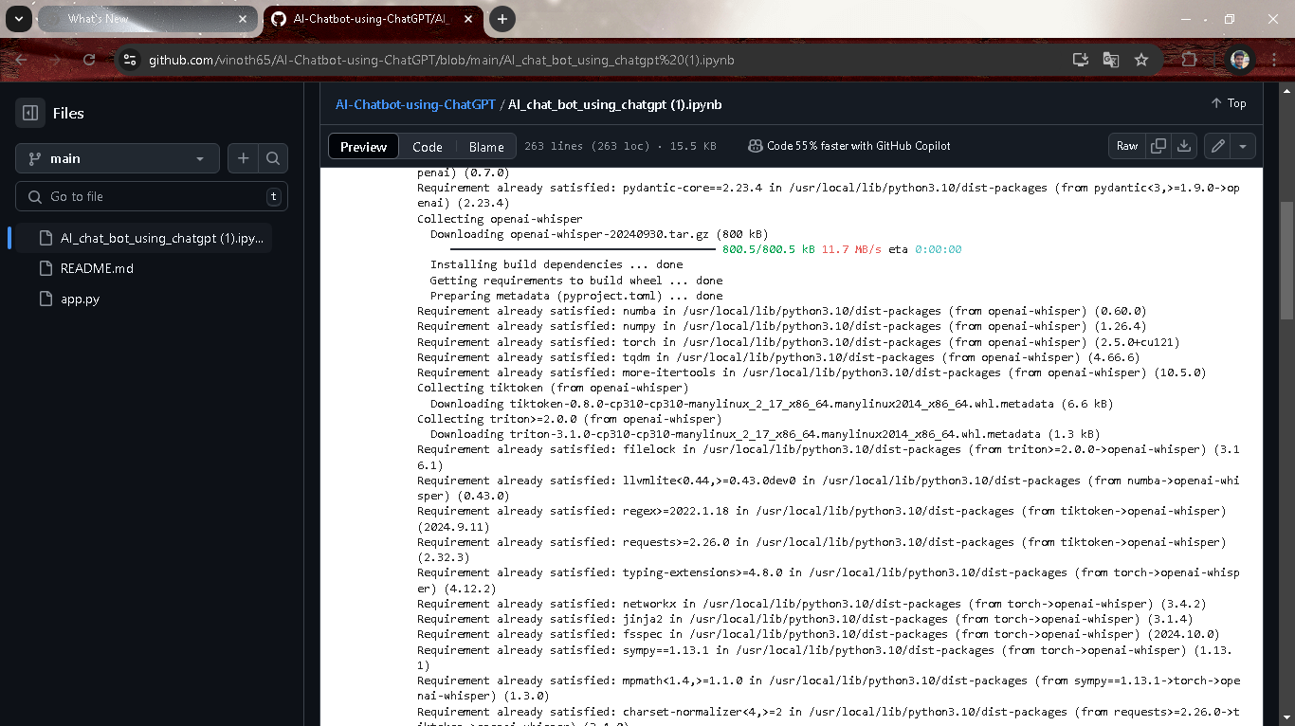

   

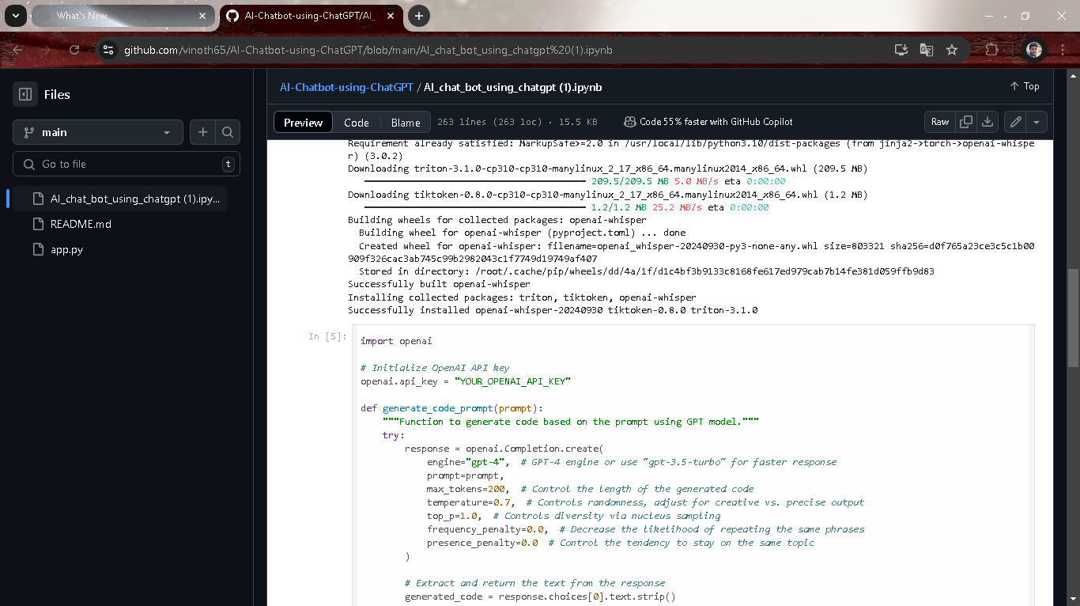

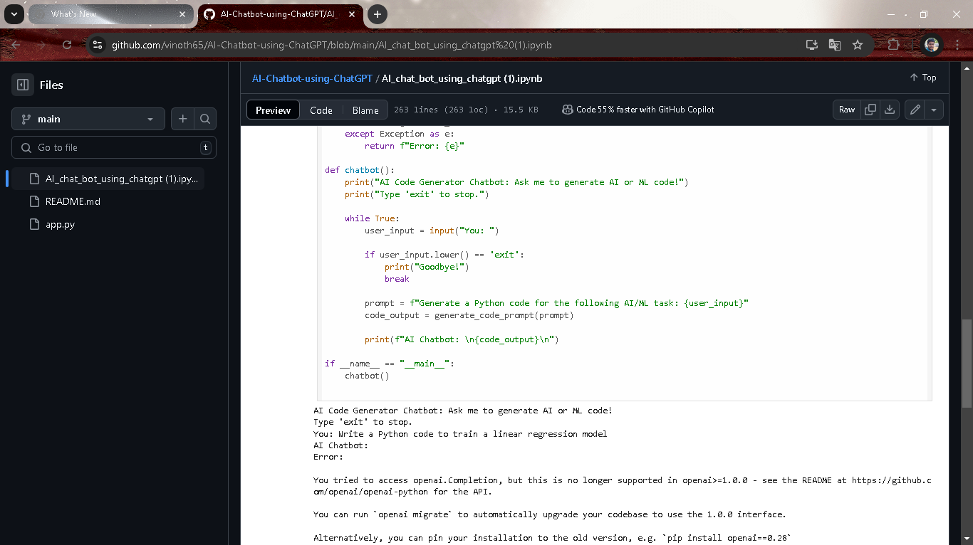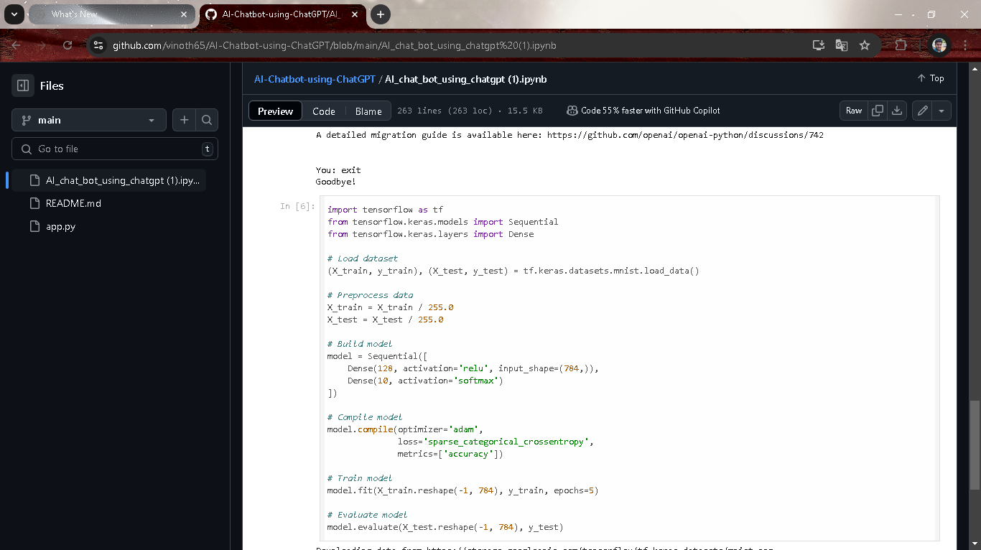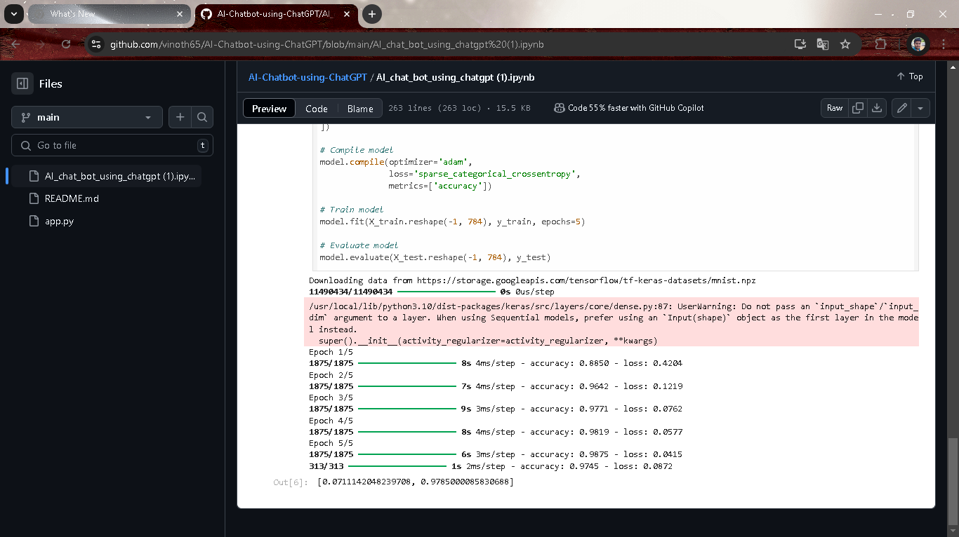

   

# CHAPTER 5

**Discussion and Conclusion**

The development of an AI chatbot using ChatGPT represents a significant milestone in the evolution of conversational AI, offering a platform capable of handling complex queries, providing coherent responses, and retaining conversational context. However, despite its powerful capabilities, ChatGPT-based chatbots still face several challenges that need to be addressed for broader adoption in real-world applications.

**Response Accuracy and Coherence**: ChatGPT shows a remarkable ability to generate human-like responses in most scenarios. However, response accuracy can vary, particularly with ambiguous or highly specialized queries. Fine-tuning and reinforcement learning can enhance accuracy, but there is a balance to maintain between general language understanding and domain specificity.

**Context Retention**: Maintaining context across multiple turns is critical for a seamless conversational experience. ChatGPT’s transformer-based architecture supports short-term context retention well, yet it faces limitations in long-term memory, impacting performance in extended conversations. Solutions like dynamic context buffers or hybrid architectures with memory modules are promising avenues to address this limitation.

**Safety and Ethical Considerations**: ChatGPT’s application in conversational AI raises ethical questions related to response safety, bias, and handling of sensitive topics. Although safety filters and ethical guidelines are in place, no system is entirely free from potential biases embedded within its training data. Continuous monitoring, bias mitigation strategies, and ethical guidelines are essential to ensure responsible usage.

**User Satisfaction and Personalization**: User satisfaction is generally high, with positive feedback on the chatbot’s responsiveness and natural conversational style. However, personalization remains challenging due to privacy concerns and data limitations. Implementing dynamic, context-aware responses tailored to individual users without storing personal data is an ongoing research focus, especially in applications where privacy is paramount.

**Scalability and Integration**: ChatGPT-based chatbots have shown the ability to scale across multiple platforms, providing consistency in user experience. However, the technical requirements of integrating across devices, such as mobile and web, can introduce challenges in performance, particularly in latency-sensitive environments. Scalability is also essential to handle high user volumes, requiring optimized server configurations and load balancing mechanisms.

   

**Git Hub Link of the Project: https://github.com/vinoth65/AI-Chatbot-using-ChatGPT.git**

   

# CHAPTER 6

# REFERENCES

**· LIDDY, E. D**

. (2001). "Natural language processing." Encyclopedia of Library and Information Science, 71(1), 1-15.

* Discusses the historical development of natural language processing and its applications in chatbots, focusing on the transition from rule-based to AI-driven conversational agents.

**· SHAWAR, B. A., & ATWELL, E**

. (2007). "Chatbots: Are they really useful?" LDV Forum, 22(1), 29-49.

* Analyzes early chatbot technology, providing a background on how chatbot applications and effectiveness have evolved over time.

·  **Brown, T., Mann, B., Ryder, N., Subbiah, M., Kaplan, J., Dhariwal, P., ... & Amodei, D.** (2020). "Language models are few-shot learners." Advances in Neural Information Processing Systems, 33, 1877-1901.

* Introduces GPT-3, the foundation for ChatGPT, explaining how few-shot learning capabilities enable the model to perform well with minimal task-specific data.

**· OPENAI. (2023). "GPT-4 TECHNICAL REPORT.**

" arXiv preprint arXiv:2303.08774.

* The official technical report for GPT-4, discussing model architecture, training, capabilities, and limitations, and providing insight into the latest advancements in language models.

**· VASWANI, A., SHAZEER, N., PARMAR, N., USZKOREIT, J., JONES, L., GOMEZ, A. N., ... & POLOSUKHIN, I**

. (2017). "Attention is all you need." Advances in Neural Information Processing Systems, 30, 5998-6008.

* Describes the transformer model architecture, which underpins the ChatGPT language model and has become a key technology in modern NLP.